John Ye

[Company name]  [Company address]

[Document title]

|  |  |  |  |
| --- | --- | --- | --- |
| Name of Student | Jonathan Tanuwijaya | ID | 18399 |

**Assessment – Research and Questioning**

Contents

Instructions: 1

Business Scenario 1

Task 1: Determine support areas 2

Task 2: Identify stakeholders 2

Task 3: Develop support procedures 2

Task 4: Assign Support Personnel 2

Task 5: Short Answer Questions 3

Task 6: Multiple Choice Questions 3

Search Index 8

# Instructions:

This is an individual assessment. Answer all the questions on the document provided by your Trainer.

***Duration:***

Trainer will set the duration of the assessment.

# Business Scenario

D&K Books Pty Ltd is a bookstore owned by Mr. Dean Kerr. The business occupies two levels of an office building connected by escalators and lifts. D&K Books employs approximately six sales staff, one operation manager, two administrative officers, a bookkeeper and a marketing manager. They have an Ethernet network consisting of ten PCs (Intel I3 Desktop cloned), two switches, a router and three printers. They use the QuickBooks software to manage their entire business, including sales, inventory, ordering, accounts receivable, accounts payable, payroll and employee management. They also have two EFTPOS terminals one on each floor.

D&K Books has a Linux server that stores all of the data including the QuickBooks database. The server is backed up to tape regularly. They also have a website (hosted on an Australian ISP’s server, dynamic and static pages using asp.net) on which customers can browse the product catalogue and view current specials. They also lease a telephone system from Live Telecoms. The PABX (phone system) consists of a main switchboard and five remote phones with three incoming lines and a message-on-hold queue system.

View my Web Support: <https://nathantanuwijaya.github.io/ECBR18399/>

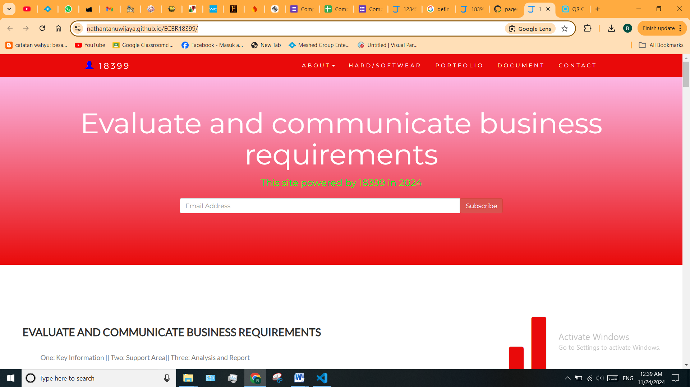

# Task 1: Determine support areas

Identify information technology (HW and SW) and list the technology in use in D&K Books and consider the following:

* What sort of support does the technology require?
* Who is likely to provide this support?
* Does the support arrangement already exist?

Present your answer in a table such as the one below:

|  |  |  |  |  |
| --- | --- | --- | --- | --- |
| **Technology** | **Description** | **Support Required** | **Provider** | **Support Already exists? (Yes/No)** |
| QuickBooks Software | Software to track accounts, stock, GST, etc. | Customization, training, upgrades, bug fixes (patching), user support. | [www.intuit.com.au](http://www.intuit.com.au) (online) | No |
| PC’s | Intel i3 Desktop clones. | Upgrades, repairs, troubleshooting, maintenance, backup, customization, networking. | JB Hi-Fi | No |
| Server | Linux Server with tape backup (may upgrade to hard disk backup). | User account management, security policy implementation, folder permissions, backups, OS patching, software installation. | Google Cloud | No |
| EFTPOS | Easy-to-use electronic payment system. | No additional support required. | Vendor support (if needed). | Yes |
| Telephone system | Low-cost communication system. | General troubleshooting and upgrades. | Optus | Yes |
| Website | Business website (low-cost hosting). | Regular updates, hosting management, and security monitoring. | Namecheap | Yes |

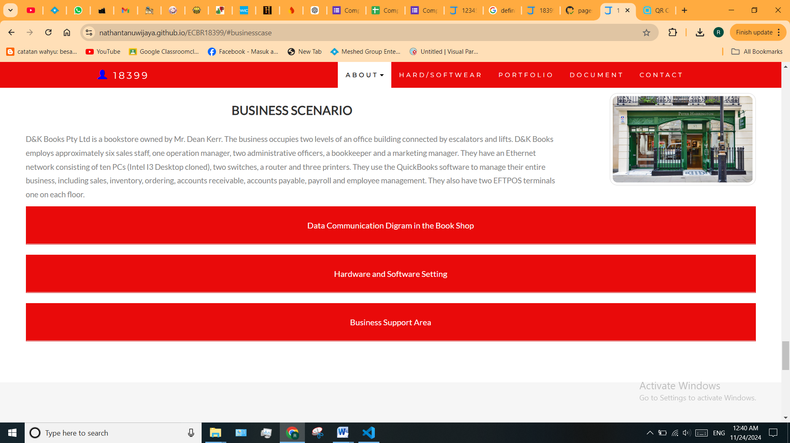

# Task 2: Identify stakeholders

Identify stakeholders related in D&K Books system

Answer:

All the staffs (the business owner, the relevant manager, the local workers and the remote workers) are stakeholders.The stakeholders for D&K Books include:

1. **Business Owner:** Makes decisions and approves system changes.
2. **Manager:** Ensures the system meets business needs.
3. **Local Workers:** Use the system for daily tasks.
4. **Remote Workers:** Need secure access to the system.

# Task 3: Develop support procedures

1. Describe one positive and one negative experience you have had when seeking assistance from a telecommunications company, an ISP or a computer supplier. Your experience may be via telephone, email or even voice recognition.
2. Using the experiences described above please answer the following questions.
   1. What support aspects were professional and/or unprofessional?
   2. How long did the support process take?
   3. Were the steps logical?
   4. Did they solve your problem?
   5. Was the call deflected to another area?

Answer:

1.

|  |  |  |
| --- | --- | --- |
| Type | Positive | Negative |
| Telephone | Easy to get answers quickly from support staff. | Lack proper documentation for reference. |
| Email | Clear communication with attached documents | Have to wait longer |
| Go to company | Face to face interaction ensures clarity. | Cost time and money spent on trip |

2.

|  |  |  |
| --- | --- | --- |
| Items | professional | unprofessional |
| What support aspects | Friendly, attentive, listening to concerns. | Not knowing the customer(Lack of understanding) |
| How long | Very quick and responsive | Long wait times. |
| Steps logical | Clear and organized process | Confusing structured steps. |
| Solve | Resolved the issue effectively | Unable to resolve the problem |
| Another area | If has, need to provide a proper resolution | If has,no resolution |

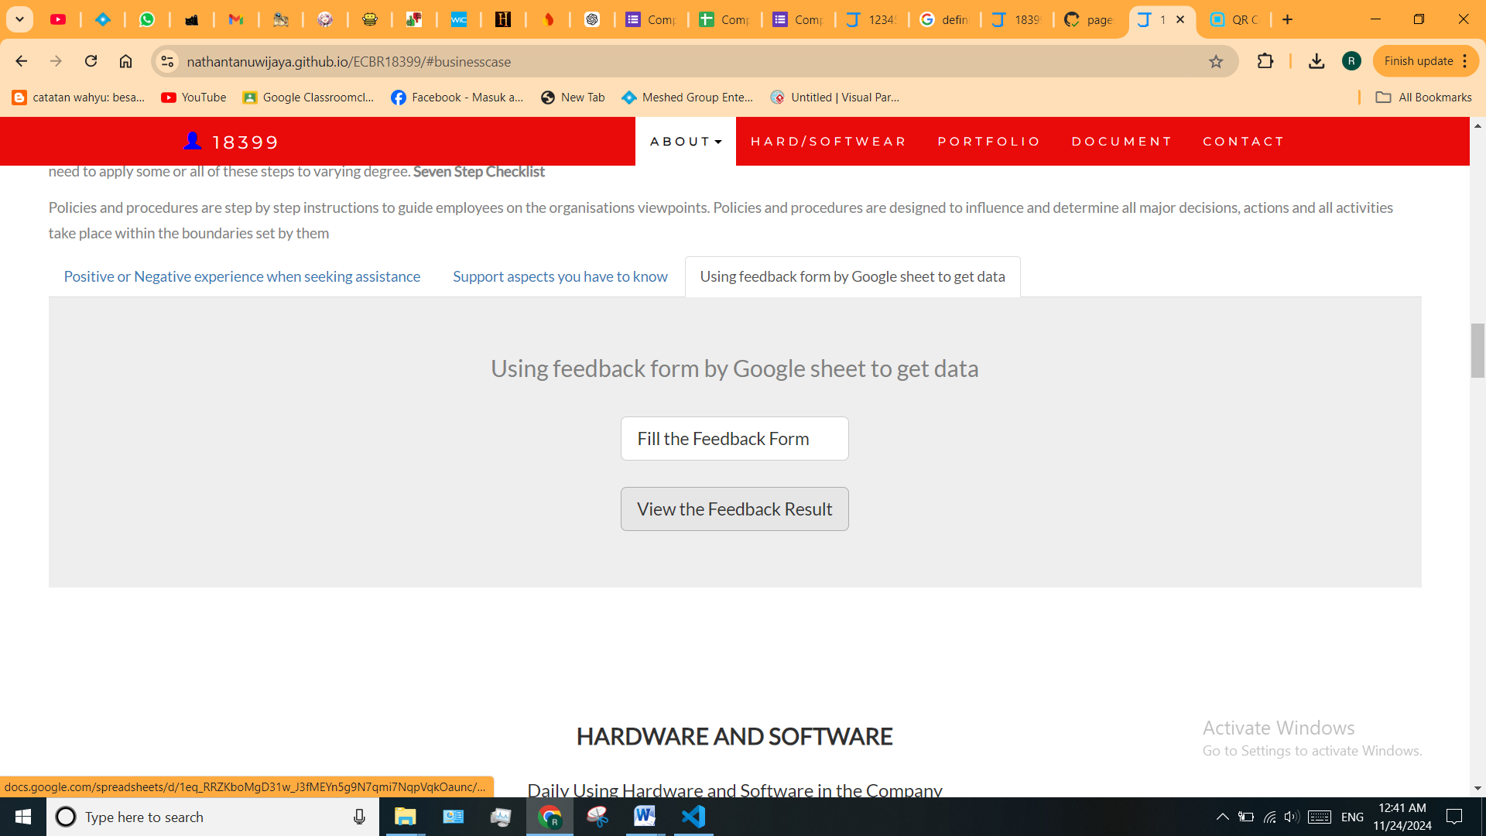

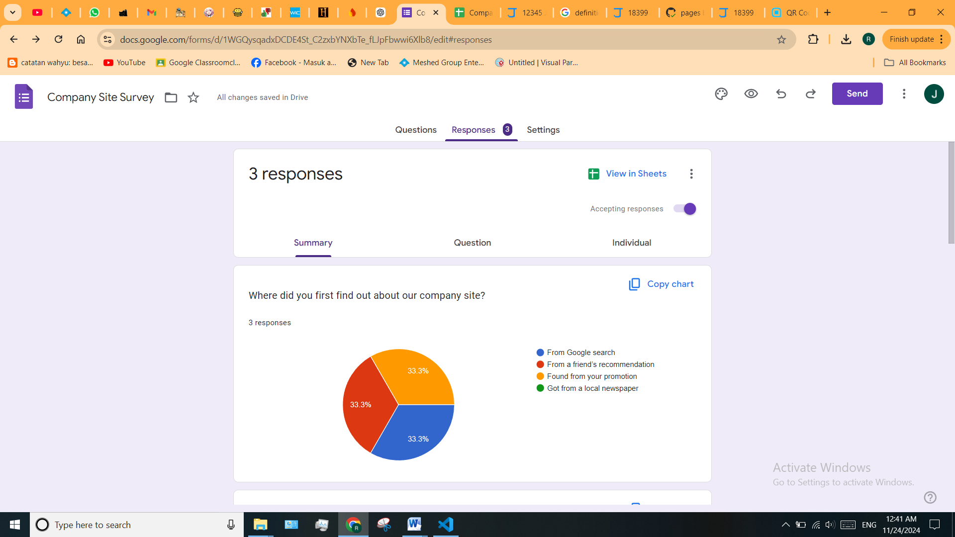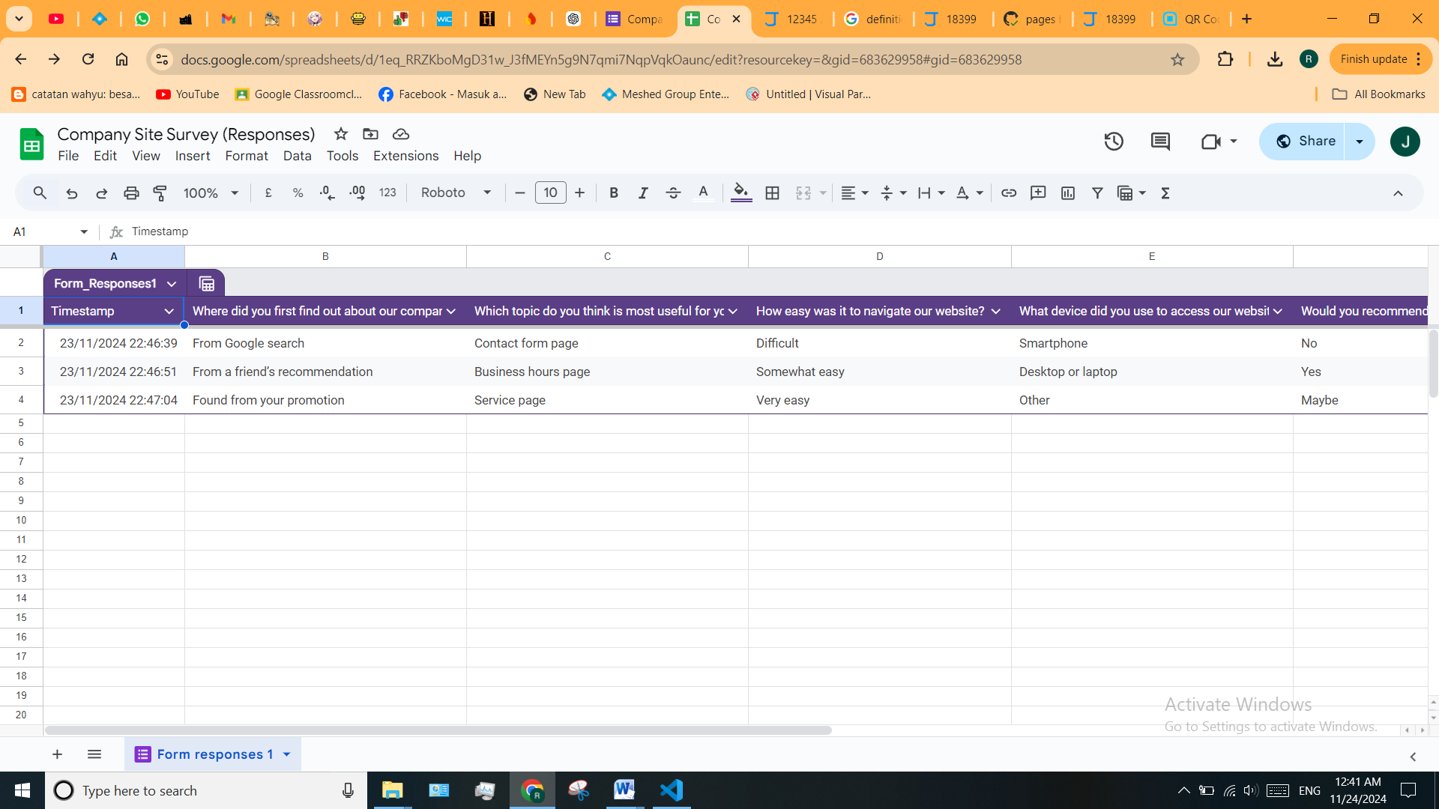

# Task 4: Assign Support Personnel

Classify the following into soft skills and technical skills. Your answer should take the form of a table shown below.

|  |  |  |
| --- | --- | --- |
| **Skill** | **Soft skill** | **Technical skill** |
| A knowledge of Linux |  | X |
| The ability to work under pressure | X |  |
| The administration of Windows 2008 Server |  | X |
| The ability to formulate network and IT policies | X |  |
| The ability to write network documentation | X |  |
| The ability to give presentations | X |  |
|  | | |

# Task 5: Short Answer Questions

1. Explain the relationship between data, information and knowledge.

Answer:

* Data: Raw facts (e.g., numbers or words).
* Information: Organized data with meaning.
* Knowledge: Using information to understand and make decisions

1. What is quantitative data and how can you use it.

Answer:

Quantitative data refers to any information that can be quantified — that is, numbers. If it can be counted or measured, and given a numerical value, it's quantitative in nature. Quantitative data is used when a researcher needs to quantify a problem, and answers questions like “what,” “how many,” and “how often.”

1. What is qualitative data and how can you use it.

Answer: Qualitative data is descriptive information that captures observable qualities and characteristics not quantifiable by numbers. It is collected from interviews, focus groups, observations, and documents offering insights into experiences, perceptions, and behaviors. qualitative research is essential for understanding “why” phenomena exist, and “how” they work, (including why and how they change or are resistant to change).

1. Give an example of how quantitative and qualitative data can be used in conjunction with each other

Answer: Quantitative and qualitative data can be used together to give a full picture.

Example:

A survey asks customers to rate satisfaction from 1 to 10 (quantitative) and explain why they gave that score (qualitative).

The numbers show how happy people are, and the explanations show why.

1. What sort of methods could you use to determine client requirements for a website design and key information sources?

Answer: Methods to Determine Client Requirements for Website Design:

* Interviews/Meetings: Talk directly with the client to understand their needs and preferences.
* Surveys/Questionnaires: Use forms to gather input on design preferences and functionality.
* Observation: Study the client’s current website or competitors’ websites.
* Workshops: Collaborate with the client to brainstorm ideas and define goals.

Key Information Sources:

* Client’s business goals and target audience.
* Competitor websites.
* Industry trends and standards.
* Feedback from end-users or stakeholders.

1. Give some examples of client requirements for a website design

Answer:

Examples of client requirements for a website design:

* Website Design Requirements
* Colour Scheme
* Fonts
* Website Content Requirements
* Images
* Text Content
* Logo
* Domain and Hosting
* Google Drive Access

# Task 6: Multiple Choice Questions

1. Generally, how many points should a rating scale have?
   1. Five
   2. Four
   3. Ten
   4. Somewhere from 4 to 11 points

Comment: A rating scale can vary in size but generally ranges between 4 and 11 points to provide adequate sensitivity without overwhelming respondents.

Web Refer: <https://brainly.in/question/31814012#:~:text=Answer,-2%20people%20found&text=Answer%3A,maintain%20too%20many%20response%20options>.

1. What is the problem(s) with this set of response categories to the question “What is your current age?” o 1-5 o 5-10 o 10-20 o 20-30 o 30-40
   1. The categories are not mutually exclusive
   2. The categories are not exhaustive
   3. Both a and b are problems
   4. There is no problem with the above set of response categories

Comment: These categories overlap and are not mutually exclusive, making it difficult to categorize responses accurately.

Web Refer: <https://www.coursehero.com/file/p567ru8/What-is-the-problems-with-this-set-of-response-categories-to-the-question-What/>

1. You should mix methods in a way that provides complementary strengths and no overlapping weaknesses. This is known as the fundamental principle of mixed research.

a) True

b) False

Comment: Mixed research aims to combine qualitative and quantitative methods, leveraging the strengths of each while minimizing their weaknesses.

Web Refer: <http://mcqsquestion.blogspot.com/2011/01/methods-of-data-collection.html>

1. According to the text, questionnaires can address events and characteristics taking place when?
   1. In the past (retrospective questions)
   2. In the present (current time questions)
   3. In the future (prospective questions)
   4. All of the above

Comment: Questionnaires can collect data about past, present, or future events depending on the research objectives.

Web Refer: <https://www.studocu.com/in/messages/question/7981173/questionnaires-can-address-events-and-characteristics-taking-place-whenain-the>

1. Which of the following are principles of questionnaire construction?
   1. Consider using multiple methods when measuring abstract constructs
   2. Use multiple items to measure abstract constructs
   3. Avoid double-barrelled questions
   4. All of the above e. Only b and c

Comment: Proper questionnaire design includes using multiple items to capture complex constructs and avoiding double-barrelled questions for clarity.

Web Refer: <http://www.analytictech.com/mb313/principl.htm>

1. Which of these is not a method of data collection?
   1. Questionnaires
   2. Interviews
   3. Experiments
   4. Observations

Comment: Experiments are not considered a direct method of data collection like questionnaires, interviews, or observations.

Web Refer: <https://www.icao.int/training/TNA/Documents/methods_for_data_gathering.pdf>

1. Secondary/existing data may include which of the following?
   1. Official documents
   2. Personal documents
   3. Archived research data
   4. All of the above

Comment: Secondary data encompasses various existing sources like official records, personal documents, and archived research data.

Web Refer: <https://careerfoundry.com/en/blog/data-analytics/what-is-secondary-data/>

1. An item that directs participants to different follow-up questions depending on their response is called a ____________.
   1. Response set
   2. Probe
   3. Semantic differential
   4. Contingency question

Comment: A contingency question directs participants to follow-up questions based on their initial response, tailoring the survey flow.

Web Refer: <https://www.coursehero.com/file/p24t38q9/An-item-that-directs-participants-to-different-follow-up-questions-depending-on/>

1. Which of the following terms best describes data that were originally collected at an earlier time by a different person for a different purpose?

a) Primary data

* 1. Secondary data
  2. Experimental data
  3. Field notes

Comment: Secondary data refers to previously collected information used for new research.

Web Refer: <https://www.toppr.com/ask/en-au/question/which-of-the-following-terms-best-describes-data-that-we-originally-collected-at-an-earlier#:~:text=Secondary%20data%20is%20the%20second,report%20is%20a%20secondary%20data>.

1. Researchers use both open-ended and closed-ended questions to collect data. Which of the following statements is true?
   1. Open-ended questions directly provide quantitative data based on the researcher’s predetermined response categories
   2. Closed-ended questions provide quantitative data in the participant’s own words
   3. Open-ended questions provide qualitative data in the participant’s own words
   4. Closed-ended questions directly provide qualitative data in the participants’ own words

Comment: Open-ended questions capture qualitative data in the participant's own words, allowing for richer, more detailed responses.

Web Refer: <https://www.chegg.com/homework-help/questions-and-answers/010-researchers-use-open-ended-closed-ended-questions-collect-data-following-statements-tr-q85410215>

1. Open-ended questions provide primarily ______ data.
   1. Confirmatory data
   2. Qualitative data
   3. Predictive data
   4. None of the above

Comment: Open-ended questions primarily gather qualitative data by capturing respondents’ thoughts in their own words.

Web Refer: <https://www.nngroup.com/articles/open-ended-questions/>

1. Which of the following is true concerning observation?
   1. It takes less time than self-report approaches
   2. It costs less money than self-report approaches
   3. It is often not possible to determine exactly why the people behave as they do
   4. All of the above

Comment: Observation allows researchers to see behaviors directly, but interpreting motives can be challenging.

Web Refer: <https://www.cdc.gov/healthyyouth/evaluation/pdf/brief16.pdf>

1. Qualitative observation is usually done for exploratory purposes; it is also called ___________ observation.
   1. Structured
   2. Naturalistic
   3. Complete
   4. Probed

Comment: Naturalistic observation involves studying behavior in its natural setting, making it exploratory.

Web Refer: <http://mcqsquestion.blogspot.com/2011/01/methods-of-data-collection.html>

1. When constructing a questionnaire, it is important to do each of the following except ______.
   1. Use "leading" or "loaded" questions
   2. Use natural language
   3. Understand your research participants
   4. Pilot your test questionnaire

Comment: Avoid leading or loaded questions, as they can bias responses and reduce the validity of the results.

Web Refer: <https://www.chegg.com/homework-help/questions-and-answers/constructing-questionnaire-important-following-except-understand-participants-give-questio-q113868556#:~:text=select%20your%20sample.-,Transcribed%20image%20text:,you%20will%20select%20your%20sample>.

1. Another name for a Likert Scale is a(n):
   1. Interview protocol
   2. Event sampling
   3. Summated rating scale
   4. Ranking

Comment: The Likert Scale is often called a summated rating scale because it combines responses to multiple items.

Web Refer: <https://en.wikipedia.org/wiki/Likert_scale#:~:text=Hence%2C%20Likert%20scales%20are%20often,are%20the%20most%20applicable%20methods>.

1. Which of the following is not one of the six major methods of data collection that are used by educational researchers?
   1. Observation
   2. Interviews
   3. Questionnaires
   4. Checklists

Comment: Checklists are tools used within methods but are not standalone data collection methods.

Web Refer: <https://www.jotform.com/data-collection-methods/>

1. The type of interview in which the specific topics are decided in advance but the sequence and wording can be modified during the interview is called:

a) The interview guide approach

* 1. The informal conversational interview
  2. A closed quantitative interview
  3. The standardized open-ended interview

Comment: The interview guide approach provides flexibility while maintaining focus on pre-defined topics.

Web Refer: <https://www.chegg.com/homework-help/questions-and-answers/ed-q14-type-interview-specific-topics-decided-advance-sequence-wording-modified-interview--q85410062>

1. Which one of the following in not a major method of data collection?
   1. Questionnaires
   2. Interviews
   3. Secondary data
   4. Focus groups
   5. All of the above are methods of data collection

Comment: All listed options are valid methods of data collection used in research.

Web Refer: <https://www.questionpro.com/blog/data-collection-methods/#:~:text=Some%20common%20data%20collection%20methods,about%20the%20study's%20subject%20matter>.

1. A question during an interview such as “Why do you feel that way?” is known as

a) Probe

* 1. Filter question
  2. Response
  3. Pilot

Comment: A probe is used to encourage respondents to elaborate on their answers.

Web Refer: <https://brainly.com/question/41354526#:~:text=Explanation%3A,a%20particular%20statement%20or%20belief>.

1. A census taker often collects data through which of the following?
   1. Standardized tests
   2. Interviews
   3. Secondary data
   4. Observations

Comment: Census takers primarily use interviews to gather demographic and other information from individuals.

Web Refer: <https://www.abs.gov.au/websitedbs/d3310114.nsf/home/Basic+Survey+Design+-+Samples+and+Censuses#:~:text=A%20census%20is%20a%20collection,census%20offers%20the%20best%20solution>.

1. The researcher has secretly placed him or herself (as a member) in the group that is being studied. This researcher may be which of the following?

a) A complete participant

* 1. An observer-as-participant
  2. A participant-as-observer
  3. None of the above

Comment: A complete participant is a researcher who immerses themselves fully in the group, often without disclosing their research role.

Web Refer: <https://www.coursehero.com/file/p6fe0vsb/20-The-researcher-has-secretly-placed-him-or-herself-as-a-member-in-the-group/>

1. Which of the following is not a major method of data collection?
   1. Questionnaires
   2. Focus groups
   3. Correlational method
   4. Secondary data

Comment: The correlational method is a statistical analysis approach, not a direct method of data collection.

Web Refer: <https://www.indeed.com/career-advice/career-development/methods-of-data-collection>

1. Which type of interview allows the questions to emerge from the immediate context or course of things?

a) Interview guide approach

* 1. Informal conversational interview
  2. Closed quantitative interview
  3. Standardized open-ended interview

Comment: Informal conversational interviews adapt flexibly to the flow of conversation.

Web Refer: <https://mcqmate.com/discussion/94662/which-type-of-interview-allows-the-questions-to-emerge-from-the-immediate-context-or-course-of-things>

1. When conducting an interview, asking "Anything else? What do you mean? Why do you feel that way?," etc, are all forms of:
   1. Contingency questions
   2. Probes
   3. Protocols
   4. Response categories

Comment: Probes are follow-up questions used to clarify or expand on responses.

Web Refer: <https://www.people.vcu.edu/~pdattalo/ReviewQsAns_609.htm>

1. When constructing a questionnaire, there are 15 principles to which you should adhere. Which of the following is not one of those principles?
   1. Do not use "leading" or "loaded" questions
   2. Avoid double-barrelled questions
   3. Avoid double negatives
   4. Avoid using multiple items to measure a single construct

Comment: Using multiple items to measure a single construct is recommended to improve validity and reliability.

Web Refer: <https://www.coursehero.com/file/p3chbuu/25-When-constructing-a-questionnaire-there-are-15-principles-to-which-you-should/>

1. A customer-based Service Level Agreement structure includes:
   1. An SLA covering all Customer groups and all the services they use
   2. SLAs for each service that are Customer-focused and written in business language
   3. An SLA for each service type, covering all those Customer groups that use that Service
   4. An SLA with each individual Customer group, covering all of the services they use

Comment: Option **D** aligns with customer-based SLAs that are service-specific and written in understandable terms.

Web Refer: <https://www.proprofs.com/quiz-school/story.php?title=nzk3odazz2n8#:~:text=A%20customer%2Dbased%20Service%20Level%20Agreement%20structure%20includes%20an%20SLA,all%20the%20services%20they%20utilize>.

1. Which of the following best describes the goal of Service Level Management?
   1. To maintain and improve IT service quality in line with business requirements
   2. To provide IT services at the lowest possible cost by agreeing with Customers their minimum requirements for service availability and ensuring performance does not exceed these targets
   3. To provide the highest possible level of service to Customers and continuously improve on this through ensuring all services operate at maximum availability
   4. To ensure that IT delivers the same standard of service at the least cost

Comment: The goal of Service Level Management is to balance quality and alignment with business needs.

Web Refer: <https://quizlet.com/388062886/itil-questions-brain-dump-flash-cards/>

1. The process to implement SLAs comprises of the following activities in sequence:
   1. Draft SLAs, catalogue services, review underpinning contracts and OLAs, draft SLRs, negotiate, agree

SLAs

* 1. Draft SLAs, review underpinning contracts and OLAs, negotiate, catalogue services,
  2. Review underpinning contracts and OLAs, draft SLAs, catalogue services, negotiate, agree SLAs
  3. Catalogue services, establish SLRs, review underpinning contracts and OLAs, negotiate service levels, agree SLAs

Comment: Option **d** reflects a logical sequence in SLA implementation.

Web Refer: <https://www.cram.com/flashcards/itil-foundation-v3-questions-needing-review-3333301>

1. Which of the following is an example of a service level agreement (SLA) between an information systems support unit and a research unit in the laboratories of a large company?
   1. The maximum response time to get the system operational should it fail.
   2. The minimum ‘up-time’.
   3. The types of information that will be provided as standard.
   4. All of the above.

Comment: SLAs often include all the mentioned aspects to define service expectations comprehensively.

Web Refer: <https://www.coursesidekick.com/information-systems/1160526>

1. Some organisations bring a degree of formality to the internal customer concept by encouraging (or requiring) different parts of the operation to agree on:

a) Internal service agreements

* 1. Service level agreements
  2. Formal provision agreements
  3. Delivery agreements

Comment: Service level agreements (SLAs) formalize internal service expectations and responsibilities

Web Refer: <https://www.business.qld.gov.au/running-business/marketing-sales/sales/communicating-effectively>

# Search Index